

EEE2008: Buggy Project

PIC16F18326 and MPLab X: Common Errors and Problems

Author: Ben Stainthorpe
Module Leader: Andrew Smith
This guide is for demonstrators and students to help debug common issues which arise during programming of the PIC on MPLab X.

Initial Checks
Often the reason for errors is due to improper code formatting. Make sure all functions have semicolons if required, all variables used are declared, all functions have been spelled correctly, and brackets {} are correct.

Contents
Initial Checks 1
GPIO Functions Aren’t Turning Blue 2
Peripheral/Global Interrupt Functions Not Turning Blue 3
uint16_t Not Recognised 5
Debug is Running a Simulator and Not the Device 6
Debugging Crashes the Program 6
Can’t Change Settings on MCC / Every Change reverts back 7
Interrupt function does not run in Debugger 7

GPIO Functions Aren’t Turning Blue
When the functions (such as the GPIO toggle) do not turn blue, it is likely due to the function being misspelled, or the MCC has not generated the function as the peripheral has not been setup properly.
- Check that the function is spelled correctly. Common errors include not having the correct case (upper or lower case), or writing a 0 (zero) instead of an O (for output).
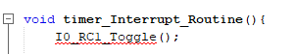
Figure 1: The function has been written with a 0 (zero) instead of an O (for output)
- Check that the peripheral has been setup properly. Reopen MCC, and visit the pin manager grid view and the pin module. In the first image below, port RC1 has correctly been ticked, in the second image analogue is unticked (as we want a digital output), and output is ticked correctly

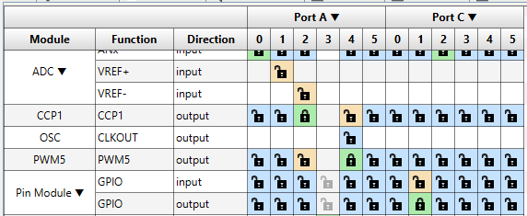
Figure 2: Correctly selecting RC1 as an output on grid view
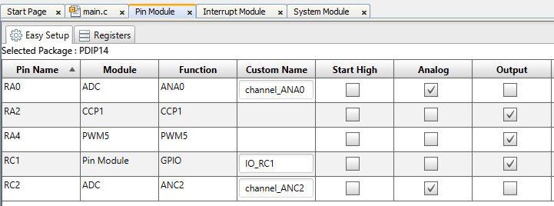
Figure 3: Correctly having RC1 analogue unticked, output ticked
- Make sure the code has been re-generated, especially if any changes have been made to the MCC setup
- Try recompiling, it is possible the function is only recognised after the compiler is ran
- If all else fails, visit the pin_manager.h file, where the function should be located (or associated peripheral C or H file). Scroll down to the functions generated for the peripheral (here is RC1). If the function is not present, then something has gone wrong in the MCC code generator. If it is present, try copying it directly from this h file – to make sure it has definitely been written correctly.
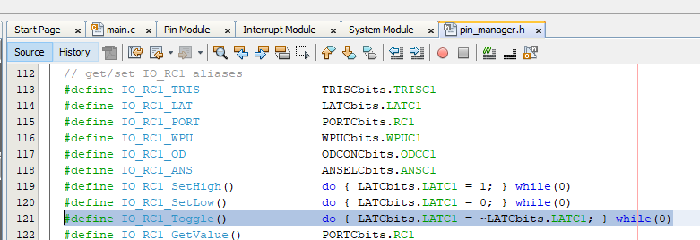
Figure 4: Location of the peripheral functions

Peripheral/Global Interrupt Functions Not Turning Blue
This is likely caused by the Interrupt Timer not being configured properly as an interrupt. Hence there are no interrupt sources and MCC has not generated the code.
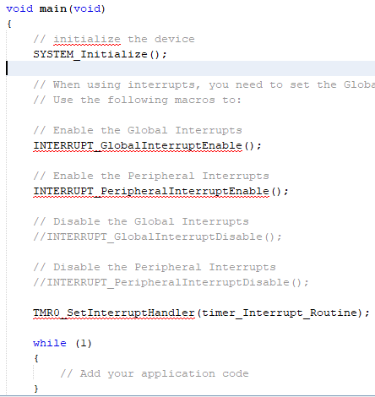
Figure 5: The Interrupt related functions are not turning blue
- Go back to the MCC setup view. Check that timer 2 has had it’s enable interrupt tick box ticked.
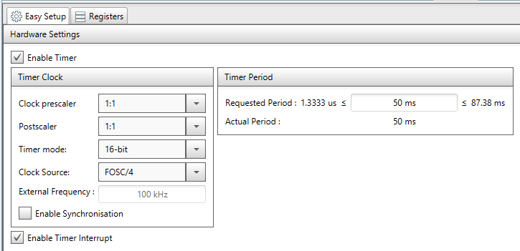
Figure 6: Timer 0 interrupt tick box
- Go to project resources > system > interrupt manager, make sure that the timer 0 interrupt is enabled here.
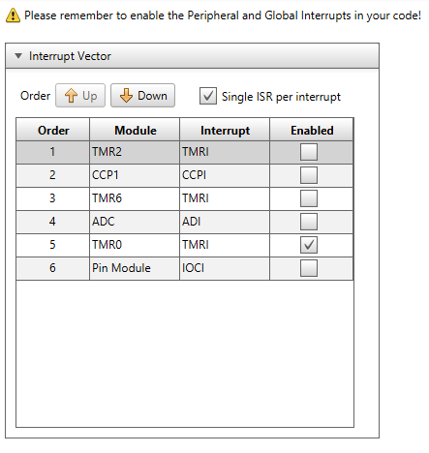
Figure 7: Interrupt list; timer 0 active
- Make sure the code has been re-generated, especially if any changes have been made to the MCC setup
- Try recompiling, it is possible the function is only recognised after the compiler is ran

uint16_t Not Recognised
Most likely, this error occurs due to being misspelled.
- Make sure it has been spelled correctly. It is ‘uint’ for unsigned int, not ‘unit’. 16 not L6.
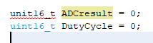
Figure 8: Incorrect spelling next to correct spelling
- Make sure the code written before the line is correct and compiling correctly – no missing libraries, no semicolon errors etc.
- Try reloading MPLab
- The only case where misspelling did not cause the compile error was not solved, and was caused by a library error – check the includes within mcc_generated_files/mcc.h, if the errors appear here such as on the stdio.h include, a larger MPLab setup error has occurred. It is best to start a new project and try again. If this occurs again, it may be an issue with the application setup, and MPLab should be reinstalled.

Debug is Running a Simulator and Not the Device
This is likely due to selecting a simulator as the debugger when initially setting up the project (see below).
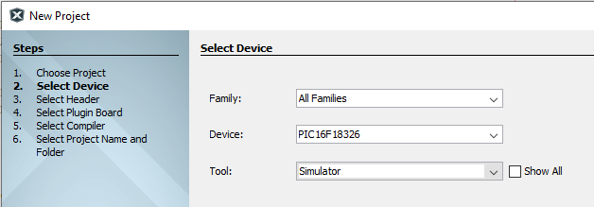
Figure 9: Simulator is Selected as Tool in setup.
The solution is to change the tool to the debugger device.
- In projects, right click on the project and go to properties. Click on the Conf:[default] tab. Change Connected hardware tool to the Snap-SN or PICkit.
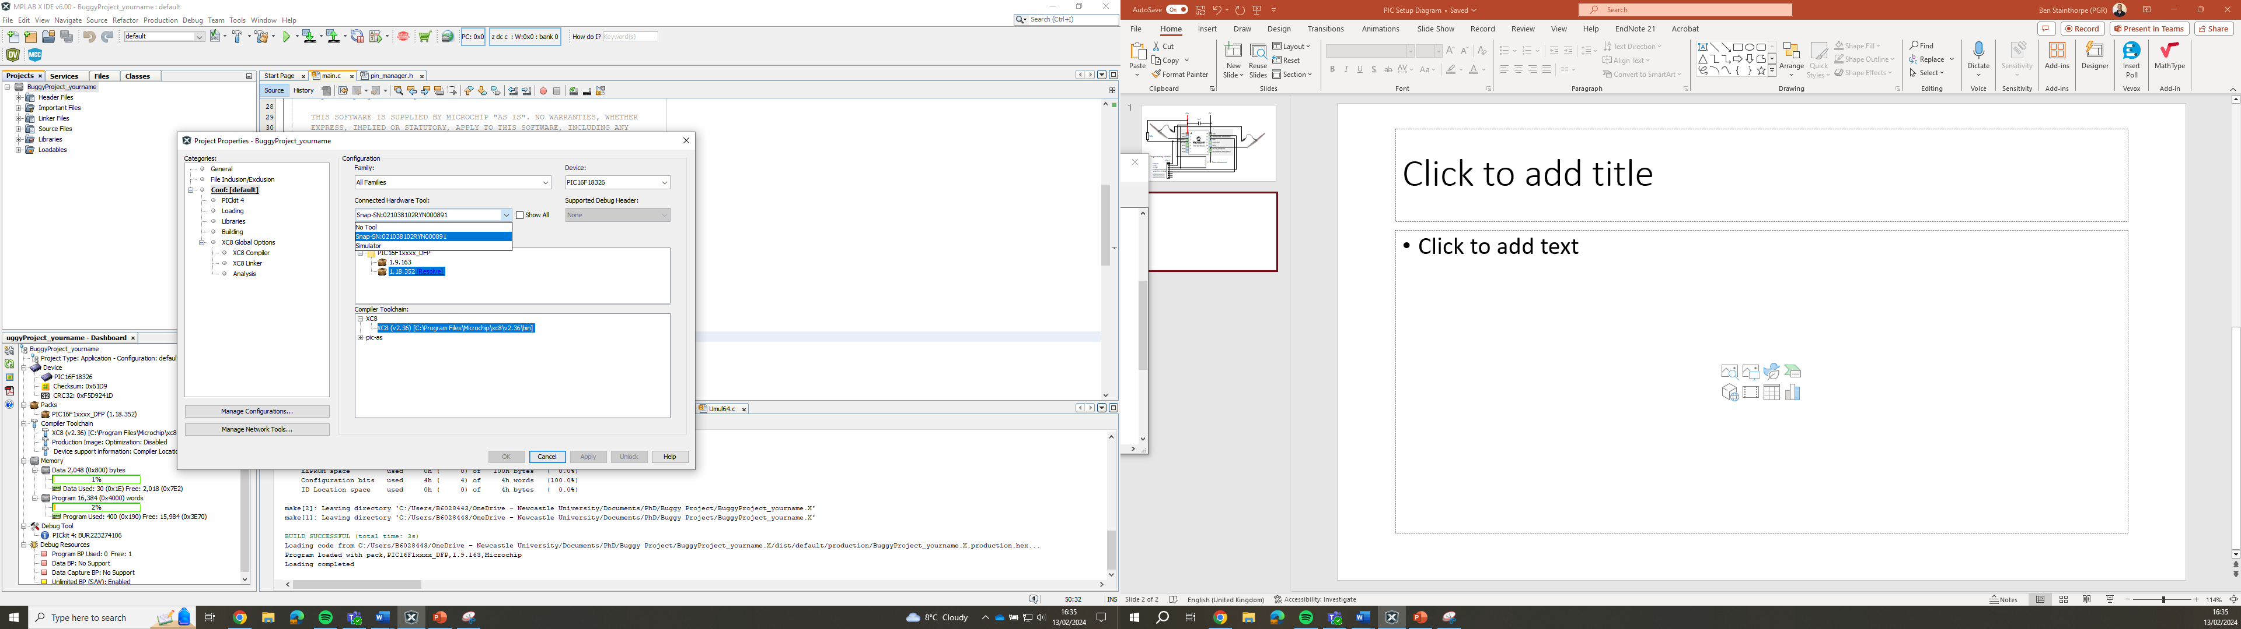
Figure 10: Changing the Tool to the Debugger

Debugging Crashes the Program
It is known that using the Snap-SN debugger on the computer lab computers causes a crash when the debugger is ran – potentially for the whole row of PCs. The solution to this is not known. Instead move to the electronics lab and use the PICkits there.

Can’t Change Settings on MCC / Every Change reverts back
This is a bug on MCC which should be fixed by reloading MPlab. If this does not solve it, try removing the module which is causing the error (use the X button next to the module on Project Resources). If this does not work, it may require starting a new project.

Interrupt function does not run in Debugger
There are many possible causes for this, but many should have triggered compiler errors.
- Within the main function, check that the global and peripheral interrupt enable (and not disable) functions are active. These were initially commented out.
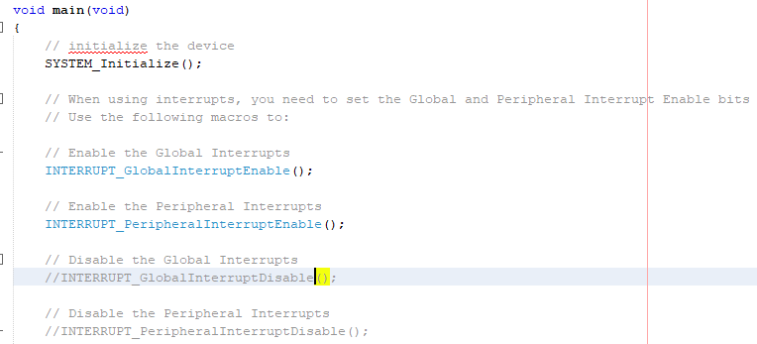
Figure 11: Enable Global and Peripheral Interrupts

